**Sweebook Guide**

**Setting Up the Environment**

1. Install Java 8, Eclipse, XAMPP, and MySQL Java Connection
2. Open XAMPP and connect Apache and MySQL

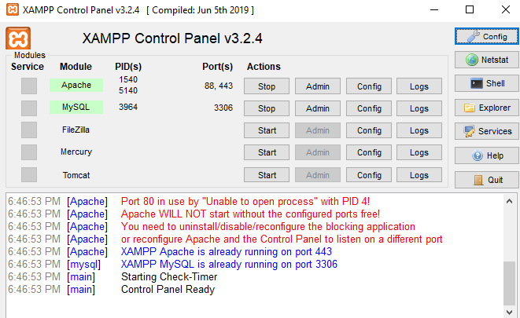

1. Open phpMyAdmin in browser

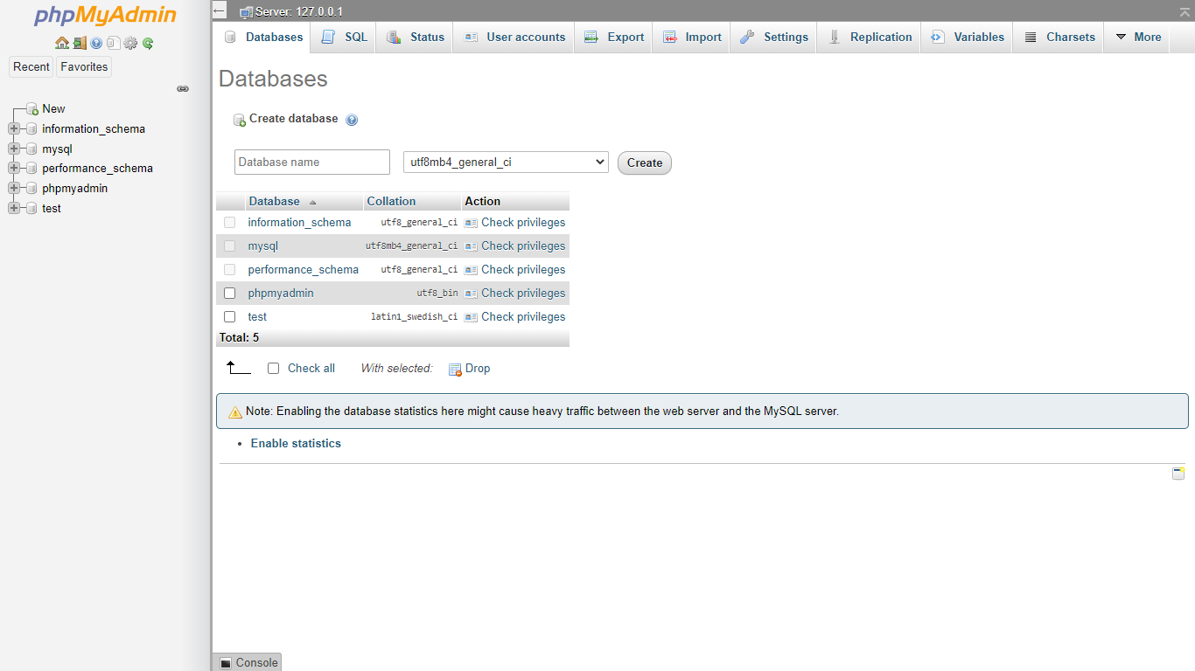

1. Go to SQL menu, type “CREATE DATABASE sweebook” and click “go” button

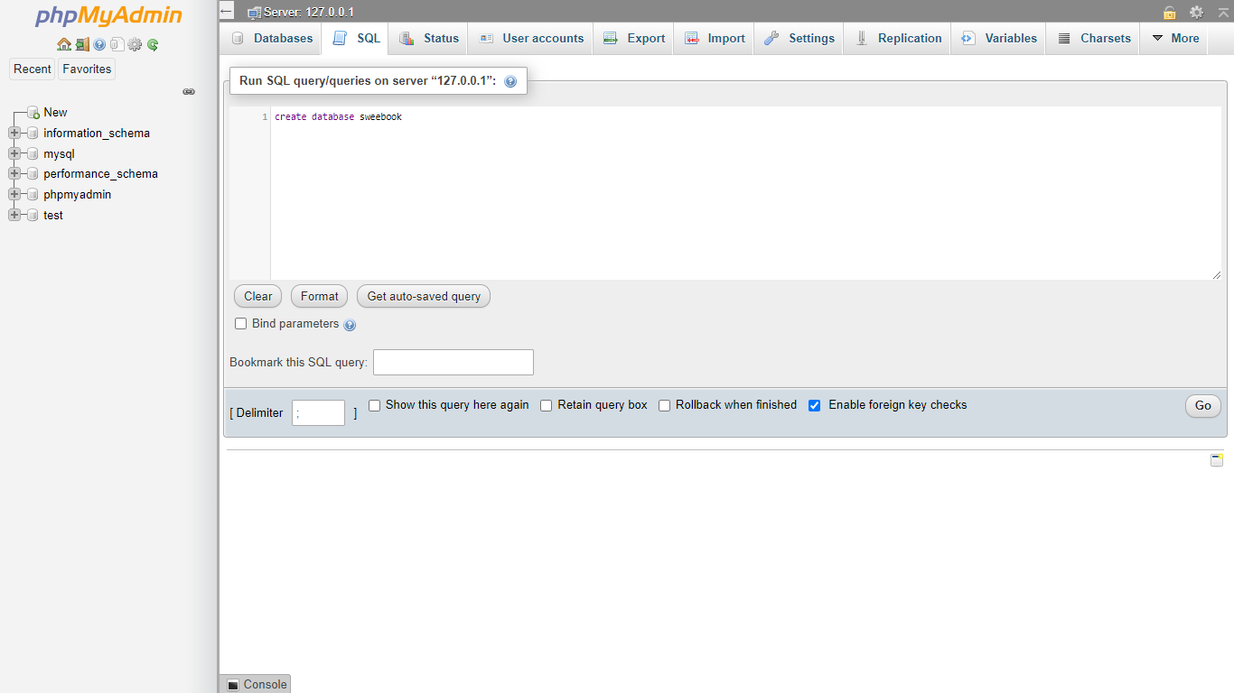

1. Click sweebook database in the left, click import menu, choose file, go to Case/sweebook.sql, click “go” button.

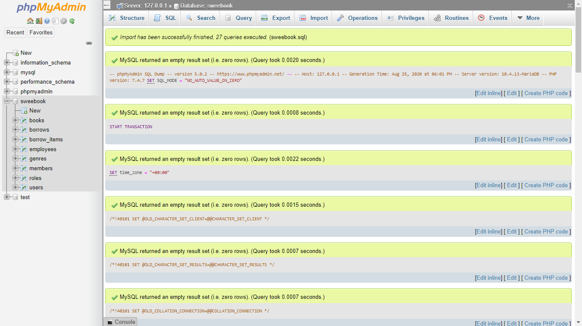

1. Open sweebook-library.exe

**Jump Right into the Program**

1. There is a Login Form. Fill the Username and password field. After filling the field, click login or just press enter button on keyboard. If username and password doesn’t match or you’re a fired or pending employee, you aren’t allowed to enter the program. If you haven’t registered a membership you can click on “Create Membership Button”. If the username and password is correct, then the main form would appear according to the user’s role.

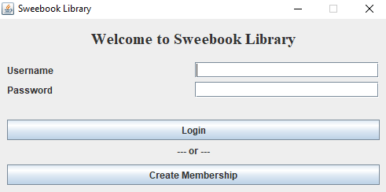

1. After clicking “Create Membership Button”, Create Membership Form would appear. Fill the field. All of the field couldn’t be empty. Username must be unique. Password has to contain minimum 8 characters alphanumeric and lowercase uppercase letter. After filling the field, click “Create Membership” button or just press enter button on keyboard. When the filled data is validated, then the Membership Main Form would appear.

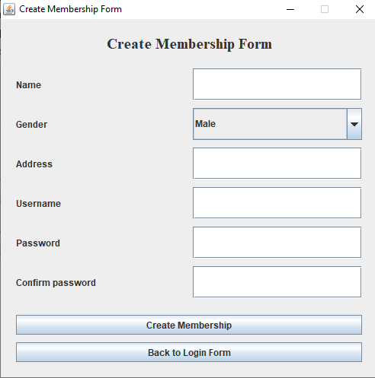

1. **Membership**
2. When the membership main form appeared, you can borrow book, view book, view pending borrows, view borrow history, and of course you can log out and switch user.

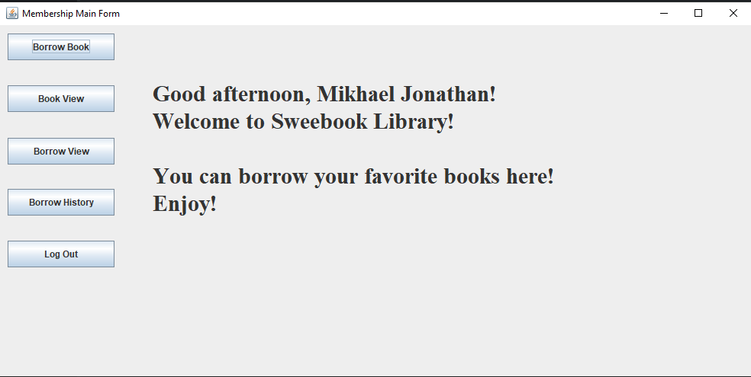

1. When you want to borrow book, just click “Borrow Book” button in the left menu. You can add or remove the books into the cart and borrow the books in the cart. You could only borrow up to 10 books and you couldn’t borrow the same book.

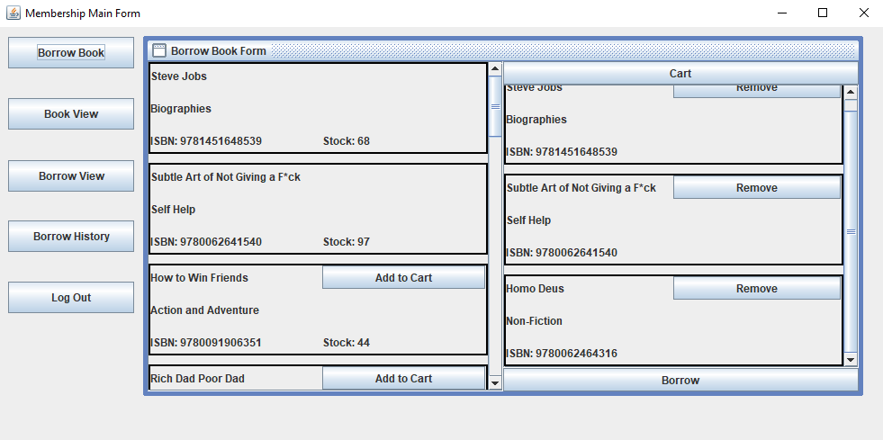

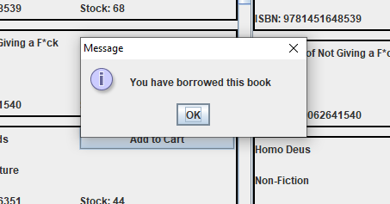

1. When you want to view book, just click “Book View” button in the left menu. It only shows list of books in our library no matter it’s available to borrow or not.

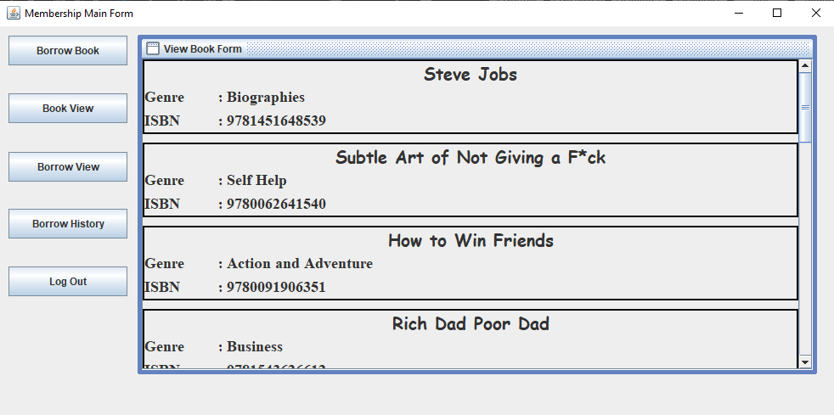

1. When you want to view pending borrow, just click “Borrow View” button in the left menu. It shows list of your pending borrows that haven’t accepted by the admin. You can click “detail” button for viewing list of books of the single borrow.

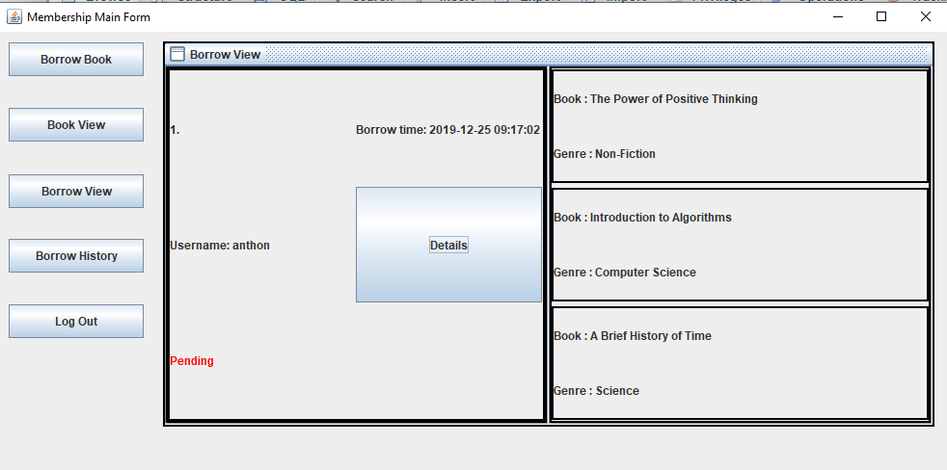

1. When you want to view borrow history, just click “Borrow View” button in the left menu. It shows the accepted borrow that you’ve ever borrowed. There is month and year spinner to show borrow of specific month and year. If you want to show all borrows without specific month and year, just set the month and year into - symbol. You could click “detail” button for viewing list of books of the single borrow. You could return the book if the book hasn’t returned. You would be given a fine if you return the book more than 2 weeks from borrowing date. The fine would be bigger if you return later.

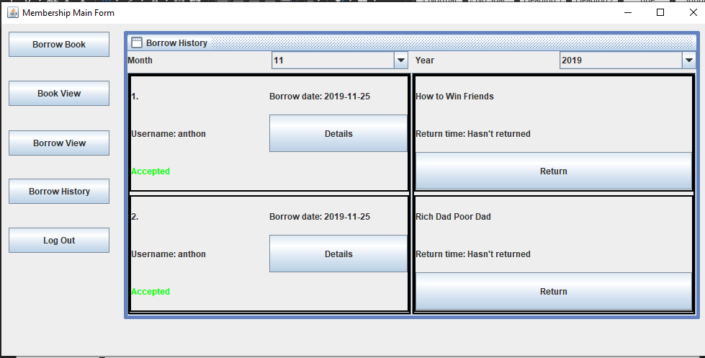

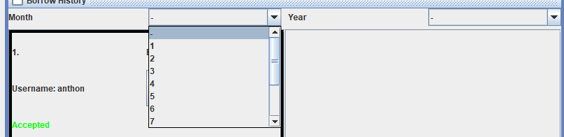

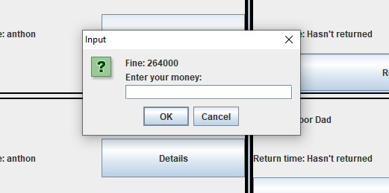

1. **Purchasing**
2. If you log in as purchasing employee, the Purchasing Main Form would appear. You can manage genre, manage book, and view book here. The view book is the same as membership.

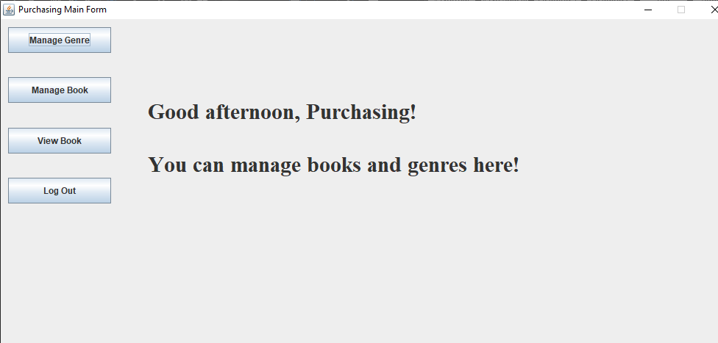

1. When you want to manage genre, just click “Manage Genre” button in the left menu. It shows the list of genres and there is a genre name field if you want to add genre. The added genre must be unique. If you’re sure to add the genre name, just click “create” button or just press enter on your keyboard.

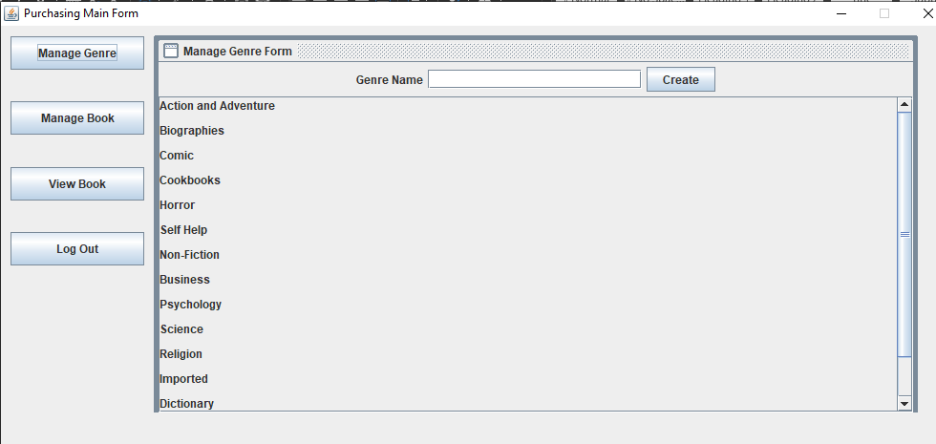

1. When you want to manage book, just click “Manage Book” button in the left menu. It shows the list of genres and the list of books in our library. If you want to delete the book in the library just pressed “delete” button on a single book. If the book is still borrowed you can’t delete the book. You also can restock or add book by typing the ISBN in the field. ISBN has to contain 10 until 13 numeric characters. Then, click “restock” button or just press enter on keyboard. If the ISBN exists, then increment the book with corresponding ISBN number by one. If not exist then “Add Book Form” would appear. You can fill the book name, genre, and quantity for the new book. Book name can’t be empty and the quantity must be in range 1 until 100. After being filled then click “ok” button or just press enter on keyboard.

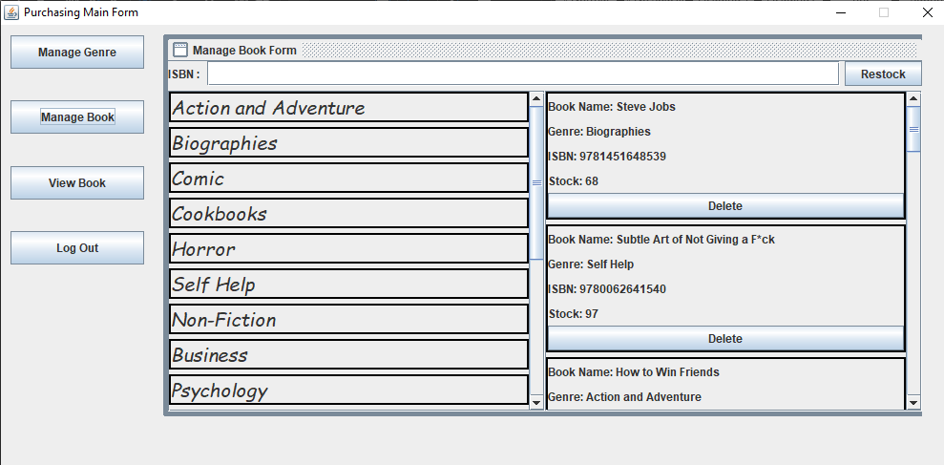

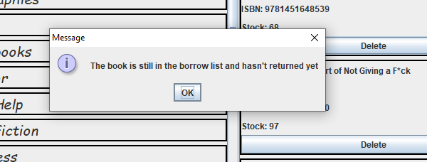

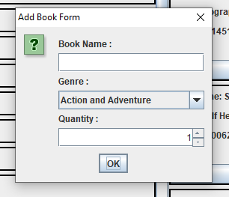

1. **Administrator**
2. If you log in as administrator employee, the Administrator Main Form would appear. You can view book, view pending borrows, view borrow history, and view membership. The “view book” functions the same as before.

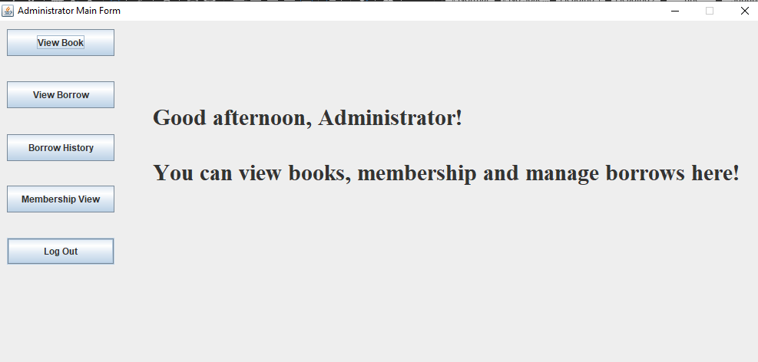

1. The “view borrow” is a little bit different. There is an additional “accept” button to accept pending borrow request from any members.

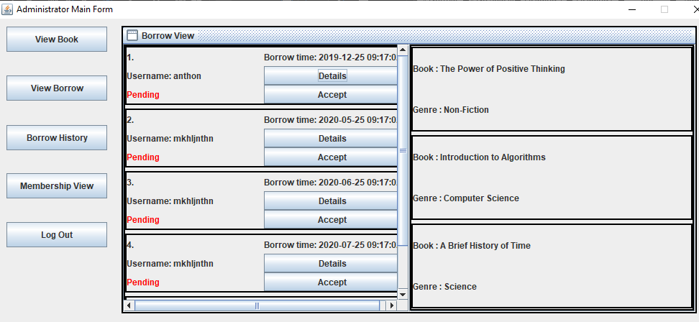

1. The “borrow history” is almost the same as before but it shows all of the accepted borrow history from all members.
2. When you want to see all the member registered, just click “membership view” button on the left menu. The “View Membership Form” would appear.

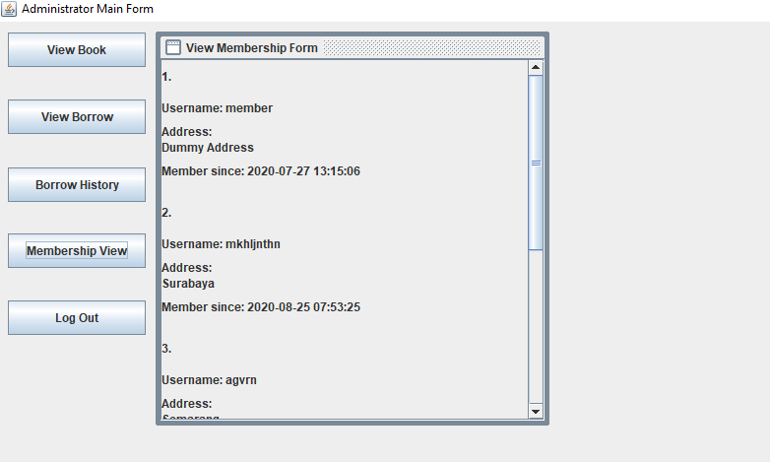

1. **Human Capital**
2. If you log in as human capital employee, the Human Capital Main Form would appear. You could only manage employee here.

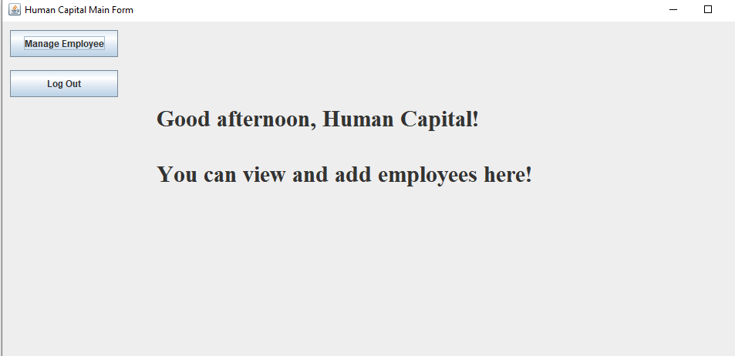

1. When you want to manage employee, just click “manage employee” button in the left menu. The Manage Employee Form would appear. It shows the list of the employee with their role and the list of the roles. There is also a form to add a new employee, of course the roles excluding membership and the manager. All of the fields couldn’t be empty, the username must be unique, and the salary must numeric and above 1000. After the field has been filled, click “Add New Employee” button or just press enter on keyboard. The status of new employee would be “Pending” and wait for the approval from the manager. The password would be generated by the program and you have to remember it.

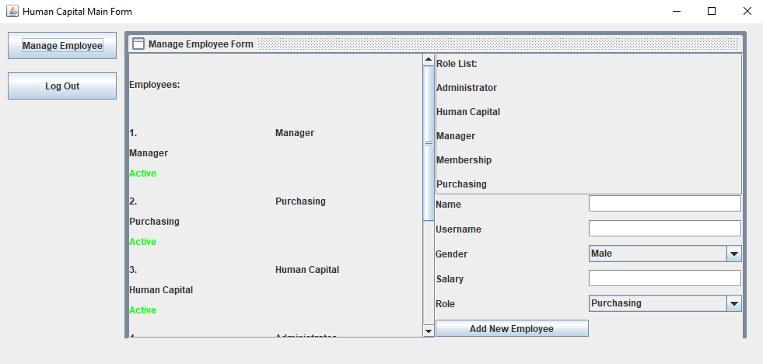

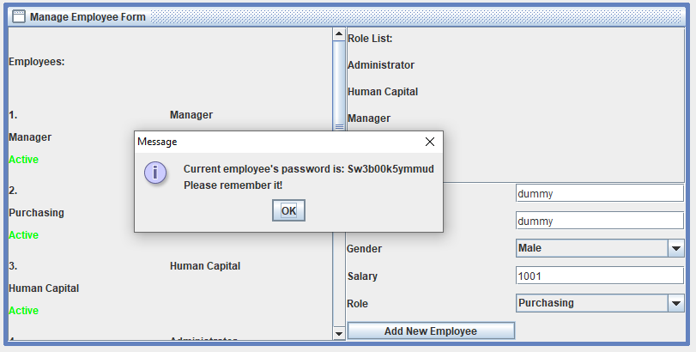

1. **Manager**
2. If you log in as manager, the Manager Main Form would appear. You can view borrow history, view membership, and manage employee. The “Borrow history” and “view membership” function the same as before.

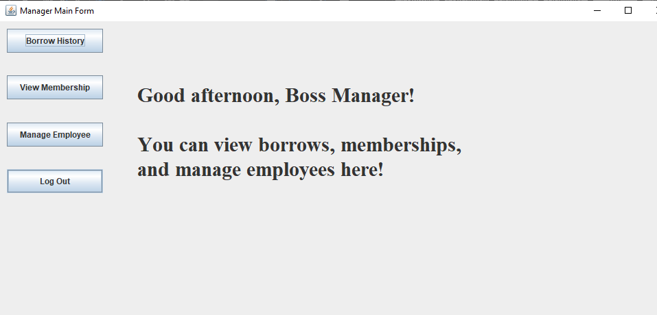

1. The manage employee menu is a little bit different as before. You can accept the employee pending request that inputted by human capital employee. Of course, the active and fired employee couldn’t be accepted. You can also fire the employee except yourself. Of course, the fired and pending employee couldn’t be fired. When you want to add employee, the employee’s status is “active”, unlike employee that inputted by human capital employee.

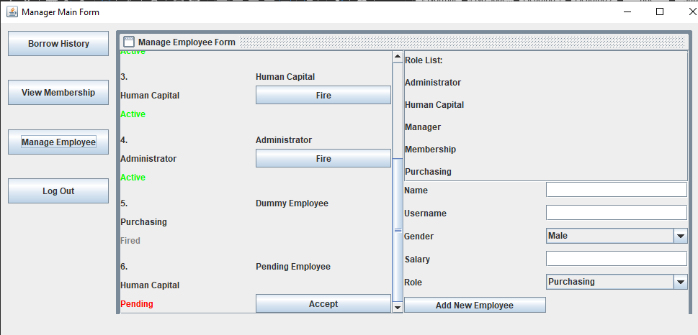

1. Available user you can test and check:

* Username: member

Password: member

Role: Membership

* Username: purchasing

Password: purchasing

Role: Purchasing

* Username: admin

Password: admin

Role: Administrator

* Username: hc

Password: hc

Role: Human Capital

* Username: manager

Password: manager

Role: Manager

* Username: agvrn

Password: Rianganteng123

Role: Membership

* Username: anthon

Password: Anthonganteng123

Role: Membership

* Username: mkhljnthn

Password: Mjganteng123

Role: Membership

* Username: dummyemployee

Password: dummyemployee

Role: Purchasing

* Username: pendingemployee

Password: pendingemployee

Role: Human Capital